Scenario 1: Quick deploy an Ec2 instance, and I need to launch a hello world website on it. Without logging in to the server. (user data)
Yes, we can do that by userdata.
We can quickly launch a website or another task without login to server and doing it.
Step 1: select lauch an ec2 instance
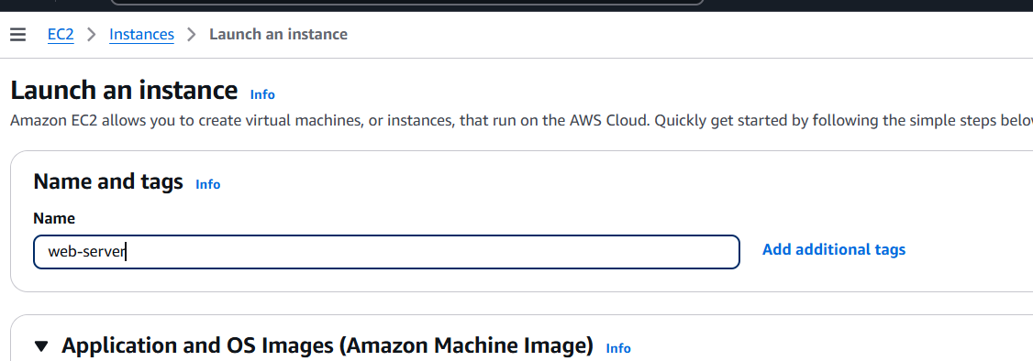
Step 2: select a OS, Amazon linux 2023 AMI
Instance type default
Key pair, as of now select” proceed without an key pair”
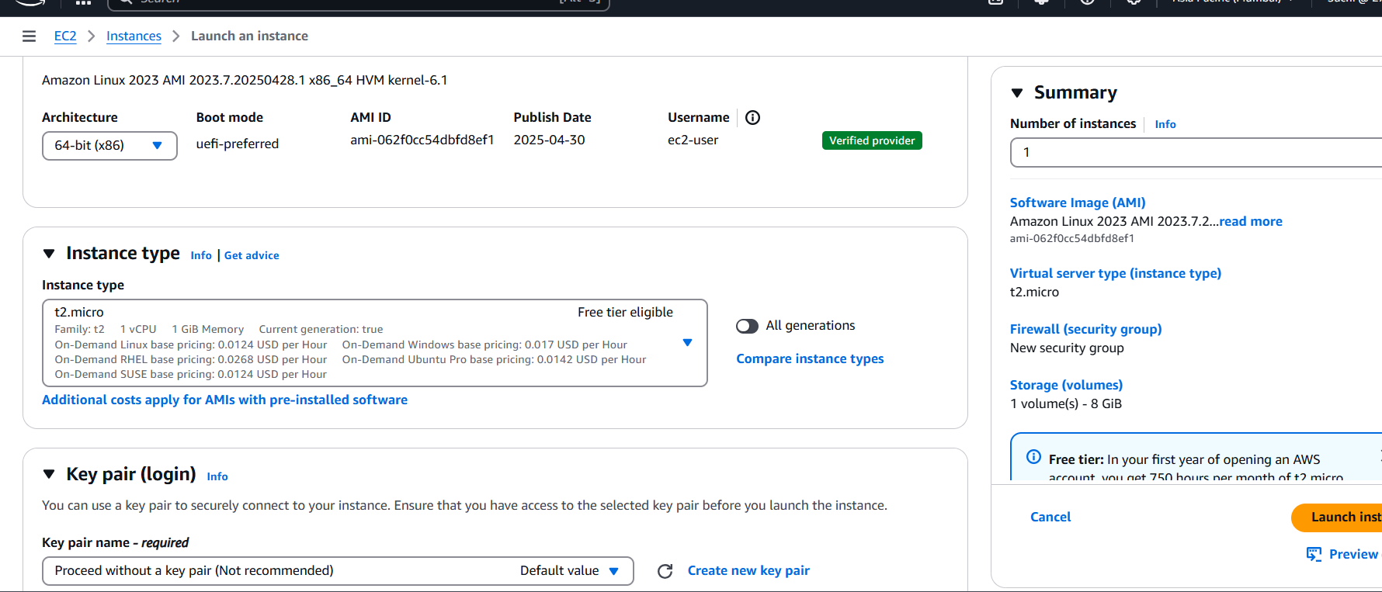
Step 3: network settings select the default ones
Note- ensure to enable public ip so that we can browse the launched website
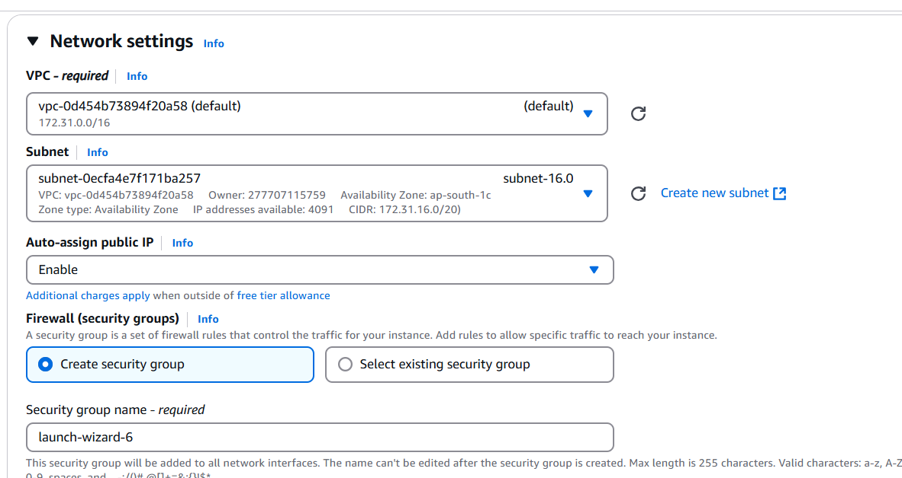
Step 4: under additional options, scroll down under user data , add the below command to create simple website.
#!/bin/bash
# Use this for your user data (script from top to bottom)
# install httpd (Linux 2 version)
yum update -y
yum install -y httpd
systemctl start httpd
systemctl enable httpd
echo "<h1>Hello World from $(hostname -f)</h1>" > /var/www/html/index.html

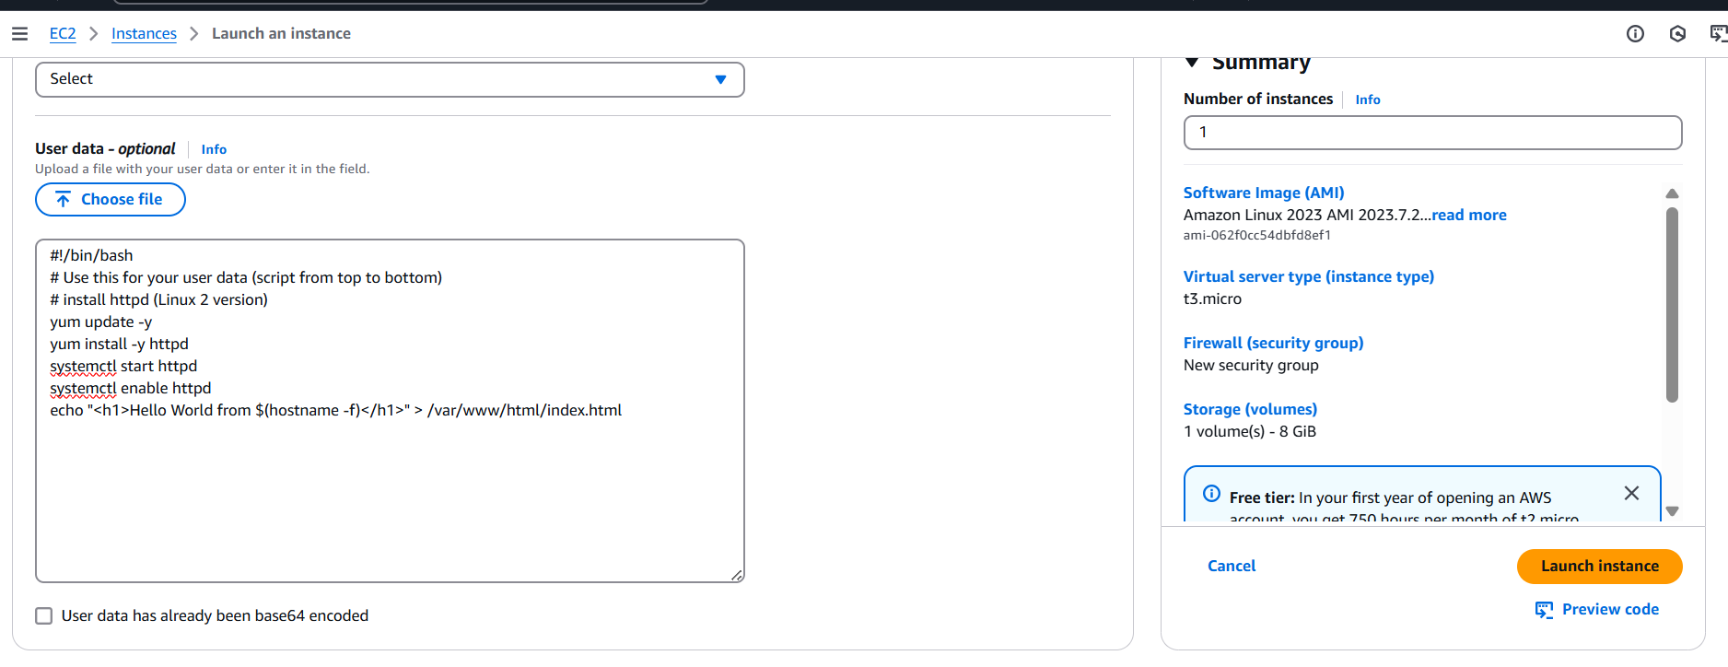
And Launch instance.
Step 5: once the status checks are passed and copy the ipv6 and browse
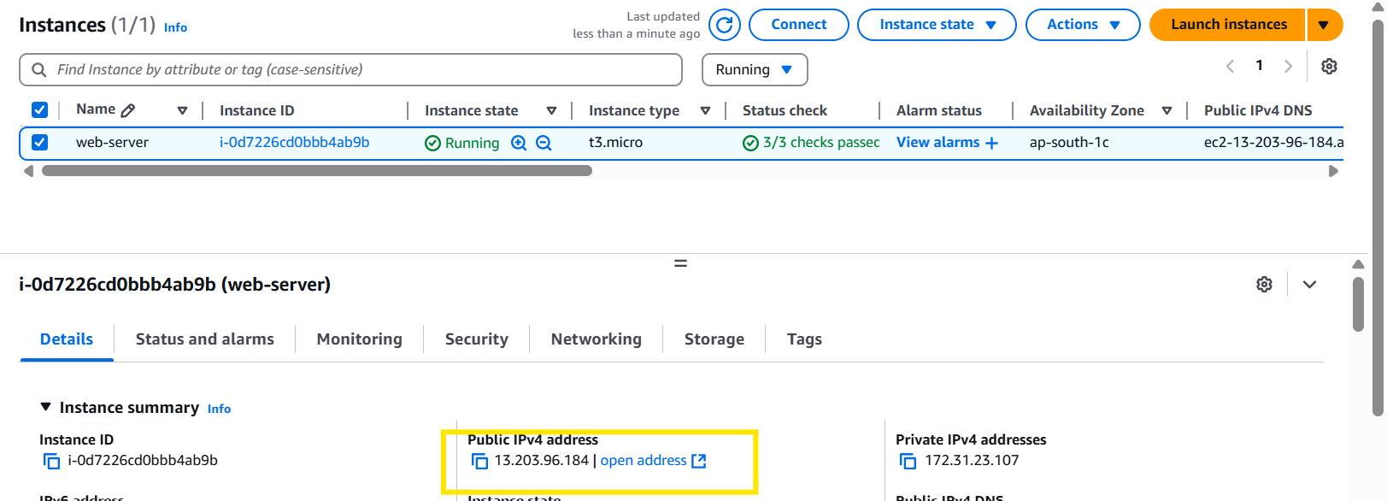

Step 6: if the website didn’t pop up, check for an inbound rules
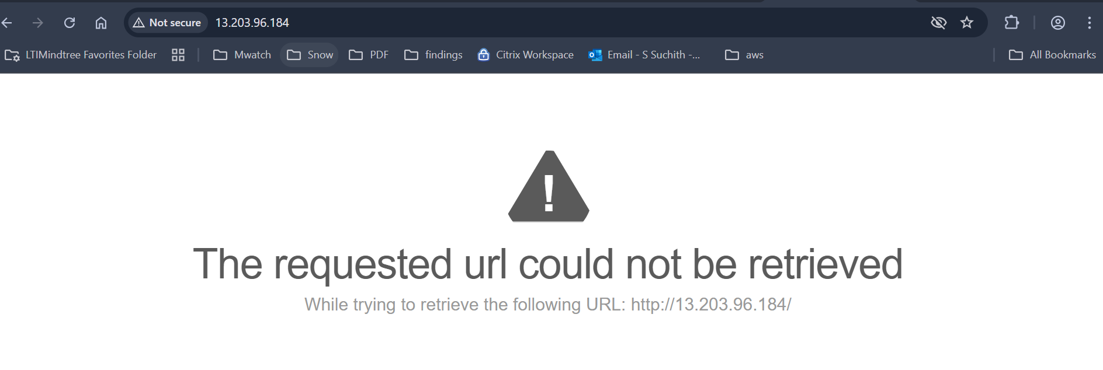
Step 7: go to security tab >click on security groups.
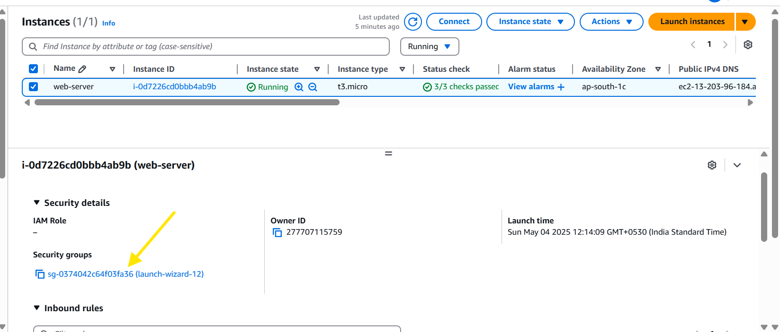
Step 8: we could see that we have only ssh connection rule.
To open /browse an website add a new rule http – port 88
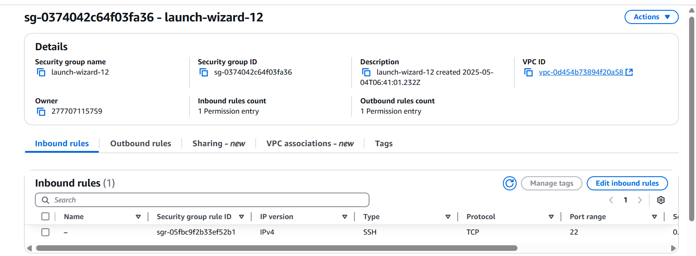
Step 9:
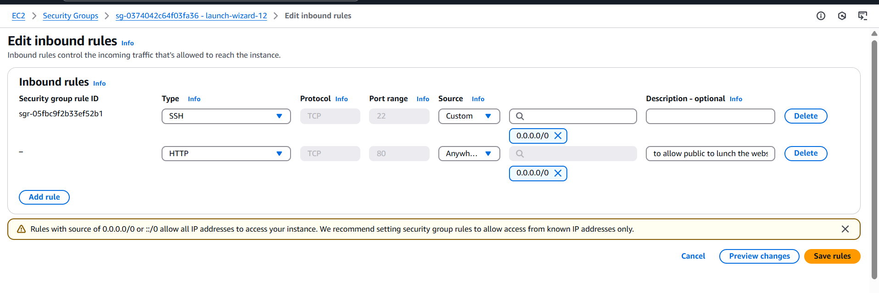
Step 10: try to browse again.
We could see that we are able to launch the website now.
